INF2003 Database Systems, Final Report
GigTrack, a live-music discovery, ticketing & memory companion
Group GXX · Members: Member 1 (lead) · Member 2 · Member 3 · Member 4 · Member 5 · Member 6
[ Replace GXX with your group number; add each member’s name + SIT email. ]

1. Introduction
GigTrack is a Ticketmaster-style web application for discovering live music, booking tickets, and reliving shows through fan-sourced setlists, reviews, and photos. Today a concert-goer juggles separate platforms for ticket purchase, lineup information, and post-show discussion; GigTrack unifies the whole journey, discover, book, and remember, into one product with two roles. Customers browse and filter concerts, book up to six tickets per show, follow artists, and post photo reviews; administrators manage the catalogue (concerts, ticket tiers, venues, artists), bookings, and user accounts through a dedicated dashboard.
The domain is a deliberate fit for this module because its data is genuinely heterogeneous, which lets us contrast relational and non-relational modelling on one dataset. Ticket inventory and money demand ACID transactions and strict integrity (a relational store); setlists and reviews are variable-shaped and append-mostly (a document store); hot listing pages and session tokens belong in an in-memory cache; and image bytes belong in object storage rather than a database. GigTrack therefore runs a polyglot back-end, MySQL, MongoDB, Redis, and MinIO, each used for what it does best.
Objectives. (1) Design a normalised relational schema with real referential integrity, constraints, triggers, and advanced queries; (2) design a justified NoSQL document model and demonstrate aggregation; (3) integrate the two stores plus a cache and object storage behind one application; and (4) evaluate the design with a reproducible performance benchmark. The value proposition in one line: the live-music companion that tracks the gig from discovery to memory.

2. Data and Datasets
We use a deterministic synthetic dataset produced by scripts/generate_seed.py with a fixed RNG seed, so every team member and marker reseeds an identical, consistent state. It is shaped like real ticketing data and respects every business rule the application enforces (seat availability, the VIP-pricing rule, and the six-ticket quota), so the seed is exactly what the app itself could have produced. The MySQL and MongoDB seeds share entity counts so integer IDs act as logical foreign keys across the two stores. Artist portraits are real images fetched once at boot and stored as blobs in object storage, not in a database.
Store | Entities (volumes)
MySQL | 21 users, 30 artists, 15 real venues across 8 cities, 50 concerts, 116 ticket tiers, ~176 confirmed bookings, 220 artist follows
MongoDB | ~25 setlists, 220 reviews (with tags/photos), 30 artist bios
MinIO | Artist portraits + review photo blobs (URL pointer kept in the DBs)
Synthetic-first was a deliberate pacing choice: it let us finish schema design, triggers, and the application early rather than fighting data cleaning in week one. Before final submission we plan to enrich the catalogue with a real public dataset (candidate sources: Kaggle concert/setlist datasets, Setlist.fm, and data.gov.sg event listings) imported through the same generator pipeline, so all constraints stay enforced.

3. Database Design

3.1 Conceptual model and translation to relations
The ER model has eight relational entities and exercises every relationship kind required by the brief. One-to-many: a venue hosts many concerts, an artist headlines many concerts, a concert offers many ticket tiers, and a ticket tier appears in many bookings. Many-to-many is realised with two junction tables: concert_artists (festival/support lineups, with slot order and role) and follows (the user–artist follow graph). Data types span VARCHAR, INT, DECIMAL (money), DATETIME, ENUM (status), and TINYINT boolean flags. Each entity maps to one table; the two junctions take composite primary keys (concert_id, artist_id) and (user_id, artist_id). The schema is normalised to 3NF, every non-key attribute depends on the whole key and nothing but the key, with no repeating groups or transitive dependencies.
▢ PLACEHOLDER, ER diagram (8 relational entities + 2 logical-FK Mongo collections)
Export docs/er_diagram.mermaid at mermaid.live (PNG/SVG) and paste it here.

Figure 1. ER diagram (8 relational entities + 2 logical-FK Mongo collections)

3.2 NoSQL document model and justification
MongoDB holds three collections whose shape varies per document, the canonical case for the document model. setlists embed an ordered song array (10–40 songs, each with duration and optional cover-of / encore / notes); reviews carry a rating, free-form tags, an array of photo pointers, and a liked_by set of user IDs; artist_bios embed nested tour history and social handles. Normalising these into MySQL would require five-plus sparse tables and a join on every read for what the app always consumes as a single unit. Storing likes as a liked_by set (not a counter) makes the helpful-count derived (len(liked_by)) and guarantees a user can never be double-counted.

3.3 The SQL–NoSQL boundary
Mongo documents reference MySQL rows by integer concert_id / user_id / artist_id, a logical foreign key that Mongo does not enforce and the application layer does. The two designs are independent but reconciled at the app tier, which is the realistic enterprise pattern and the discussion point for project task 5. Pros of independence: each store optimises for its own access pattern and Mongo schema evolution needs no MySQL migration. Cons: dangling references are possible, so the application implements the cross-store cascade itself (Section 6 and the Appendix).

3.4 Cache and object-storage layers (Redis 7, MinIO)
Two further stores complete the design. Redis is an in-memory layer with four key families, each with a deliberate TTL, reached through a single redis-py client built in app/db.py; the application uses SETEX / GET / EXPIRE for sessions, INCR with an atomic GETDEL for view counters, and JSON SET / GET for the listing cache.
Redis key pattern | Type | Purpose | TTL
session:{token} | string | auth session (user_id); slid on each request | 30 min
browse:{when}:{city}:{genre} | JSON | cached concert listing per filter | 5 min
cities:list / genres:list | JSON | filter dropdowns & category tiles | 1 hr
concert:{id}:views | counter | pending view delta, GETDEL-drained to MySQL | none
MinIO provides S3-compatible object storage for image blobs in the gigtrack-media bucket, accessed through a thin boto3 helper (app/storage.py: ensure_bucket, upload_fileobj, public_url, presigned_url, delete). The databases never hold image bytes, a review document keeps only {url, key} and MySQL keeps the artist's image_url, so the same code runs unchanged against AWS S3 or Cloudflare R2 by swapping the endpoint and credentials. The demo bucket is public-read so <img src> works directly; presigned_url() shows the time-limited signed-URL pattern for a private production bucket.

4. Relational Implementation (MySQL 8)
Full CRUD is implemented over all eight tables through parameterised statements. Integrity goes well beyond foreign keys.
- Constraints. FK + CHECK constraints back every rule: CHECK (available_seats >= 0 AND available_seats <= total_seats); concert delete cascades to tickets and concert_artists but is RESTRICTed while bookings exist.
- Four triggers. (1) BEFORE INSERT on bookings decrements seat inventory and raises SQLSTATE 45000 on oversell (rolling the transaction back); (2) AFTER UPDATE on bookings restores seats on confirmed→cancelled or confirmed→refunded; (3–4) a BEFORE INSERT / BEFORE UPDATE pair on tickets enforces that a VIP tier is never cheaper than other tiers of the same concert.
CREATE TRIGGER trg_booking_decrement_seats BEFORE INSERT ON bookings
FOR EACH ROW BEGIN
DECLARE avail INT;
SELECT available_seats INTO avail FROM tickets WHERE ticket_id = NEW.ticket_id FOR UPDATE;
IF avail < NEW.quantity THEN
SIGNAL SQLSTATE '45000' SET MESSAGE_TEXT = 'Not enough seats';
END IF;
UPDATE tickets SET available_seats = available_seats - NEW.quantity
WHERE ticket_id = NEW.ticket_id;
END;
sql/schema.sql, seat-inventory trigger (abridged)

Advanced queries (sql/queries.sql) go beyond CRUD: nested and correlated subqueries (including a relational-division “for every” query), window functions (revenue RANK() per city and a running cumulative total), a multi-step CTE, an explicit multi-statement transaction, a reusable view, and EXPLAIN evidence that the composite index serves the trending query. The booking quota (max six per user per concert) is checked and inserted in one locking transaction using SELECT … FOR UPDATE on the concert’s ticket rows, so concurrent requests cannot race past the limit.
SELECT v.city, c.title, COALESCE(SUM(b.total_price),0) AS rev,
RANK() OVER (PARTITION BY v.city
ORDER BY COALESCE(SUM(b.total_price),0) DESC) AS rk
FROM concerts c JOIN venues v ON v.venue_id = c.venue_id
LEFT JOIN tickets t ON t.concert_id = c.concert_id
LEFT JOIN bookings b ON b.ticket_id = t.ticket_id AND b.status='confirmed'
GROUP BY v.city, c.concert_id; -- window function: revenue leaderboard per city
sql/queries.sql, window-function example

Indexing. Beyond the primary keys, concerts carries a composite (status, concert_date) index that serves the date-ordered trending list, venues is indexed on city to drive the browse filter, and artists on name/genre. The figure below traces the booking path through the locking transaction and the seat trigger.
▢ PLACEHOLDER, Ticket booking, quota check + seat trigger in one transaction
Export §2 of docs/flow_diagrams.md (booking + seat trigger) at mermaid.live and paste here.

Figure 3. Ticket booking, quota check + seat trigger in one transaction

5. Non-relational Implementation (MongoDB 7 + object storage)
CRUD on all three collections runs through PyMongo (mongo/queries.py). Indexes include a compound (concert_id, posted_at) for review listing, a unique artist_id, and a text index powering full-text review search. Aggregation pipelines use $group and $unwind, plus two showcase operators: $facet computes the whole rating dashboard (rating distribution + top tags) in a single pass, and $lookup performs a document-side join of reviews to setlists.
db.reviews.aggregate([{ $facet: {
byRating: [{ $group: { _id: '$rating', n: { $sum: 1 } } }, { $sort: { _id: -1 } }],
topTags: [{ $unwind: '$tags' }, { $group: { _id: '$tags', n: { $sum: 1 } } },
{ $sort: { n: -1 } }, { $limit: 5 }]
}}]) // one-pass multi-metric rating dashboard
mongo/queries.py, $facet aggregation

Likes are toggled with $addToSet / $pull on the per-user liked_by set, so a double-click never double-counts, a single atomic update with no join table. Object storage follows a strict pointer-vs-blob pattern: review and artist images live as bytes in a MinIO S3-compatible bucket (app/storage.py), while the databases keep only a URL pointer plus structured metadata (caption, order). Documents have a 16 MB cap and putting image bytes in a database bloats the working set and backups; object storage is purpose-built for large immutable blobs and swaps to AWS S3 / Cloudflare R2 by changing only the endpoint and credentials. The demo uses a public-read bucket so <img src> works directly; storage.presigned_url() shows the time-limited signed-URL alternative for production.
▢ PLACEHOLDER, Review with photo, bytes to object storage, pointer to the DBs
Export §3 of docs/flow_diagrams.md (review / photo pointer-vs-blob) at mermaid.live and paste here.

Figure 4. Review with photo, bytes to object storage, pointer to the DBs

6. Application and System
The Flask application (~30 routes) coordinates all four stores. A single user action often touches several: MySQL is the source of truth (identity, inventory, bookings, follows), MongoDB holds rich content (setlists, reviews, bios), Redis provides speed (cache, sessions, view counters), and MinIO holds media bytes. Figure 2 traces the core journey across all four datastores.
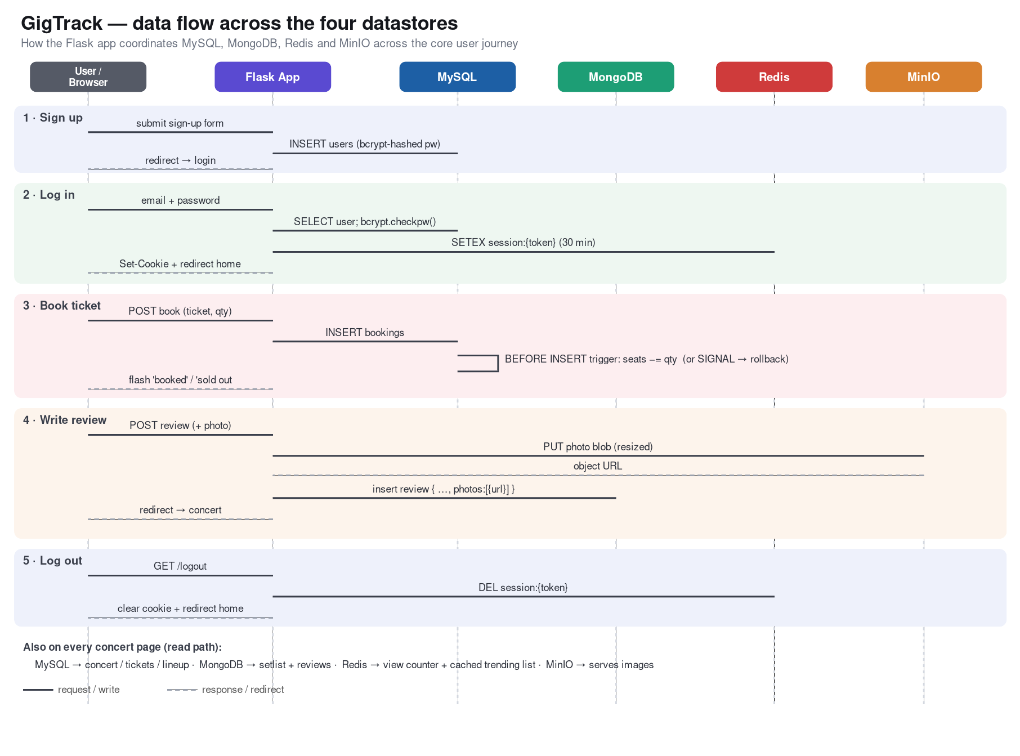
Figure 2. GigTrack data flow across the four datastores (docs/data_flow.svg).
Caching strategy. Building on the Redis key design in §3.4, listing pages are served cache-aside (a hit skips the three-table join entirely), view counts use a write-behind GETDEL that drains into MySQL only before a view-ordered render so counting stays lossless yet off the hot path, and any admin create/edit/delete immediately busts the affected browse, cities, and genres caches.
Key features. Booking enforces a six-per-concert quota inside one locking transaction (race-safe); the admin dashboard does full concert/ticket/user CRUD, can add a brand-new artist and venue inline in the same transaction, and on delete performs an application-level cascade across the SQL–NoSQL boundary (removing the concert’s Mongo setlists/reviews and their MinIO photo blobs) so no orphans remain.
Security. All SQL is parameterised (injection-safe); passwords are bcrypt-hashed; every state-changing form carries a CSRF synchroniser token; session cookies are HttpOnly and SameSite=Lax with a sliding 30-minute Redis-backed expiry; uploaded images are type/size-validated and downscaled; and administrator accounts cannot purchase tickets.

7. Performance Evaluation
scripts/benchmark.py measures six scenario groups, cached vs uncached reads, indexed vs full-scan, a per-store point-lookup ladder, server-side compute, write latency including trigger cost, commit batching, and concurrent throughput, each over 300 iterations, reporting latency percentiles, client CPU per call, throughput, and peak memory (≈52 MB for the run). Figure 5 summarises all six groups across MySQL, MongoDB, and Redis; the table below lists the headline scenarios.
Scenario (store) | avg ms | p95 ms | ops/s
Redis cached read | 0.13 | 0.18 | 7,460
MySQL uncached 3-table join | 8.94 | 11.69 | 112
Redis GET (point lookup) | 0.10 | 0.13 | 9,759
MySQL PRIMARY-KEY lookup | 8.34 | 9.71 | 120
MySQL INSERT (plain) | 2.30 | 3.44 | 434
MySQL INSERT + seat trigger | 2.83 | 4.82 | 353
MySQL, 1 commit / 50 rows | 12.92 | 26.11 | 77
MySQL, 50 commits / 50 rows | 144.65 | 210.85 | 7
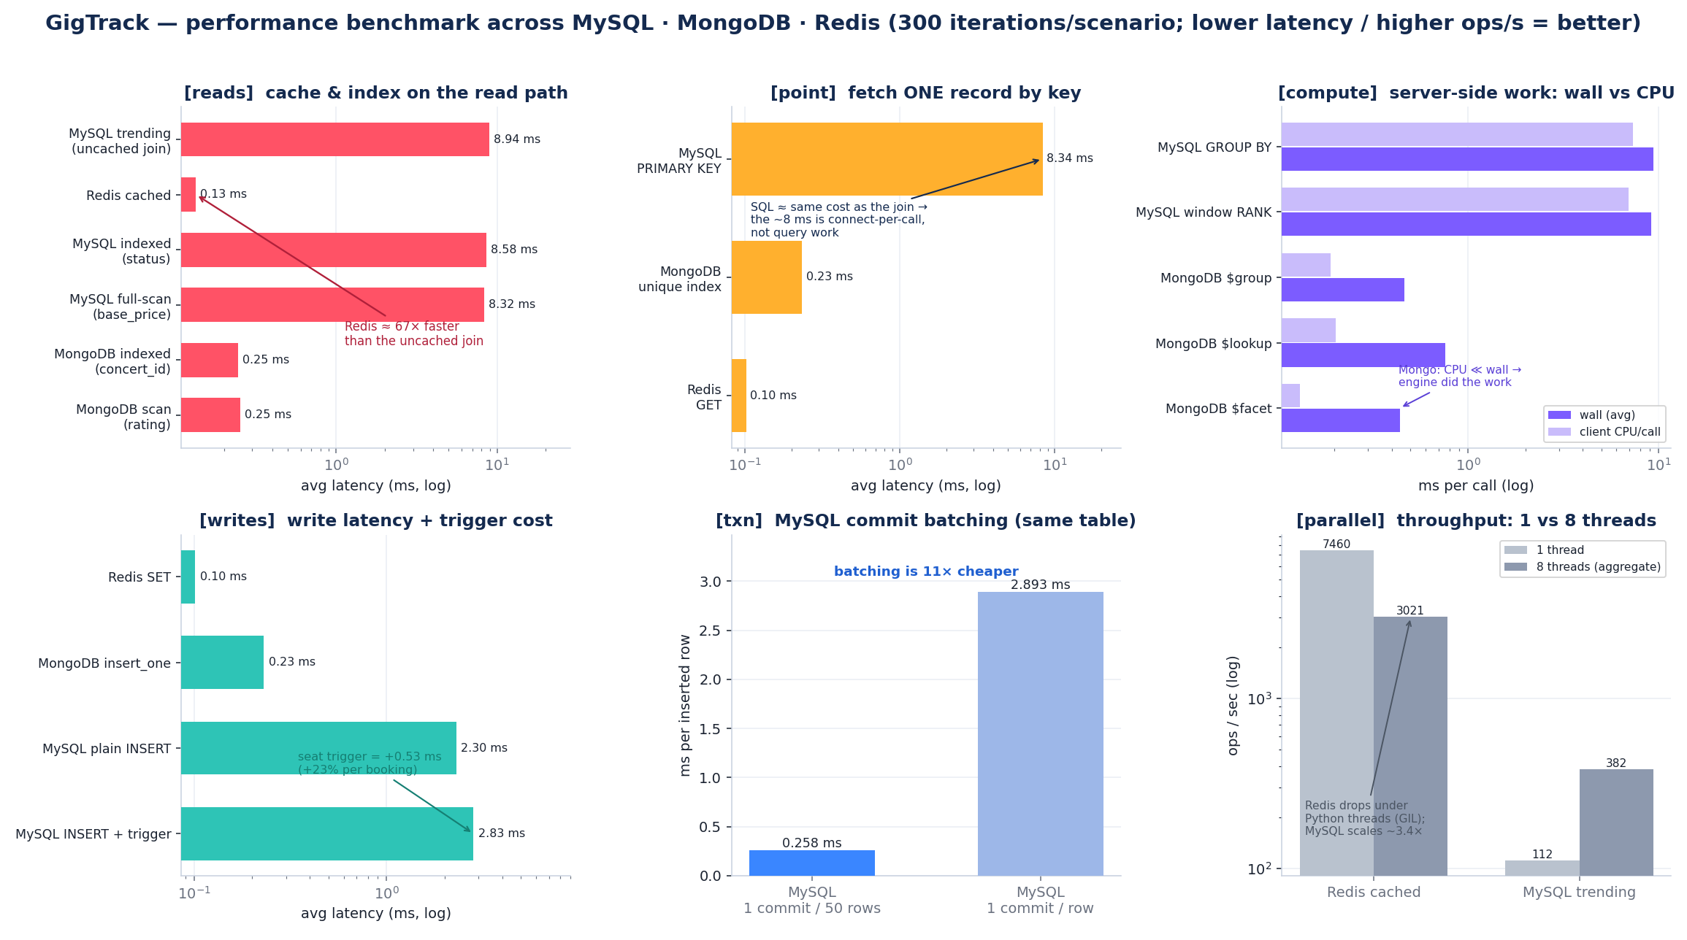
Figure 5. Six-group benchmark across MySQL, MongoDB and Redis (last two table rows are the same MySQL table, comparing commit strategy).
Analysis. The headline is the cache: a warm Redis read serves the trending payload in 0.13 ms against 8.94 ms for the uncached three-table MySQL join, roughly 67× lower latency and 67× higher throughput (7,460 vs 112 ops/s). The point-lookup ladder is just as stark: a Redis GET (0.10 ms) and a MongoDB unique-index find_one (0.24 ms) versus 8.34 ms for a MySQL primary-key lookup. Crucially, that primary-key lookup costs almost exactly the same as the full join (8.34 vs 8.94 ms), the query work is sub-millisecond, and the ~8 ms floor is the cost of opening a fresh connection on every call, since the app does not pool connections. The write scenarios, which reuse one connection, confirm this: a plain INSERT is only 2.30 ms. A connection pool is therefore the single highest-impact optimisation, noted as future work.
Indexing showed no measurable benefit at seed volume on either store (MySQL indexed 8.58 ms vs full-scan 8.32 ms; MongoDB ~0.25 ms either way): at 50 concerts the planner scans regardless, so index value is better shown via EXPLAIN or at larger scale. The seat-inventory trigger is cheap, 2.83 ms with the trigger vs 2.30 ms plain, a +0.53 ms (+23%) price for guaranteed inventory integrity. Commit batching, compared on the same MySQL table, is ~11× cheaper per row (one commit per 50 rows vs one per row; ≈2.69 ms per extra fsync), which is why the seed loader emits multi-row INSERTs. Under concurrency (8 threads) MySQL throughput scaled ~3.4× as each thread used its own connection, whereas the Redis path fell (7,460→3,021 ops/s) because Python’s GIL serialises client-side JSON parsing, Redis stays far faster per call but does not scale with threads. Correctness is verified separately by a pytest suite (11 unit + 14 integration tests).

8. GenAI Reflection
We used GenAI assistants for scaffolding (route stubs, the seed generator skeleton, Docker/compose boilerplate), for drafting and proofreading prose, and as a faster reference for SQL window-function and MongoDB aggregation syntax. The clear pros were speed on boilerplate and a lower barrier to trying unfamiliar operators such as $facet and RANK(). The cons were real: assistants occasionally produced plausible-but-wrong SQL, invented PyMongo options, or suggested non-atomic like-counting that we had to correct. Our takeaway for future projects is to treat GenAI as a junior pair-programmer, great for first drafts and explanations, but every generated query, trigger, and security control must be verified against the official docs and our own tests, and core design decisions (the schema, the SQL–NoSQL boundary, the trigger logic) should stay human-owned.

9. Conclusion and Future Work
GigTrack delivers a working polyglot application that demonstrates the full range of module skills: a normalised relational core with foreign keys, CHECK constraints, four business-rule triggers, and advanced queries; a justified MongoDB document model with text search and $facet / $lookup aggregation; a Redis cache/session/counter layer; and S3-compatible object storage, all integrated behind a secure Flask UI and validated by a reproducible benchmark and an automated test suite. Future work: import a real public dataset through the existing pipeline, add a payment gateway, build a recommendation feed from the follow graph and review tags, and move to managed/replicated datastores for horizontal scale.

Appendix

A. Additional flow diagrams (export from docs/flow_diagrams.md)
▢ PLACEHOLDER, Login & session, bcrypt verify + sliding Redis session
Export §1 of docs/flow_diagrams.md at mermaid.live and paste here.

Figure 6. Login & session, bcrypt verify + sliding Redis session
▢ PLACEHOLDER, Browse caching & view counters (cache-aside + write-behind)
Export §4 of docs/flow_diagrams.md at mermaid.live and paste here.

Figure 7. Browse caching & view counters (cache-aside + write-behind)
▢ PLACEHOLDER, Concert delete, cross-store cascade (MySQL → MinIO → Mongo → Redis)
Export §5 of docs/flow_diagrams.md at mermaid.live and paste here.

Figure 8. Concert delete, cross-store cascade (MySQL → MinIO → Mongo → Redis)

B. Relational schema summary
Table | Key design points
users | UNIQUE username/email, bcrypt hash, is_admin / is_active flags
artists | name + genre indexes; image_url points at object storage
venues | city/country/capacity; city index drives the browse filter
concerts | FKs to venue + headline artist; ENUM status; (status, concert_date) index
concert_artists | M:N junction, lineup slots (order, role); cascade on concert delete
tickets | tiers per concert; CHECK (available_seats >= 0 AND <= total_seats)
bookings | quantity, total price, ENUM status; FKs to user and ticket; RESTRICT delete
follows | M:N junction, composite PK (user_id, artist_id), cascade delete

C. Redis key patterns
Key pattern | Purpose | TTL
concert:{id}:views | pending view delta drained into MySQL (GETDEL) | none
browse:{when}:{city}:{genre} | cached listing per filter combination | 5 min
cities:list / genres:list | distinct cities / genres for filters & tiles | 1 hr
session:{token} | auth session (sliding) | 30 min

D. Source-code submission screenshots
The source-code zip may include up to ten screenshots of advanced features for the marker. Suggested set (replace each bracket with an actual screenshot): [admin concert form with inline artist/venue creation], [oversell attempt blocked by the trigger], [six-ticket quota error], [review with photo + MinIO object], [redis-cli MONITOR showing a cache hit], [pytest run all green].

E. Production considerations (real-world deployment)
GigTrack runs locally via Docker Compose, but each store maps cleanly onto a managed, horizontally scalable production deployment. The application code does not change; only configuration (endpoints, credentials, pool sizes) does.
Store | How it runs in production
MySQL | Primary with read replicas (reads scale out, writes stay consistent); a connection pool removes the per-request connect cost measured in Section 7; row-level locking and transactions preserve correctness under concurrency; automated backups + point-in-time recovery.
MongoDB | Deployed as a replica set for high availability and automatic failover; sharding spreads large collections across nodes for horizontal scale; server-side aggregation and flexible schema evolution need no migrations.
Redis | Redis Cluster / Sentinel for high availability and key sharding; AOF/RDB persistence so sessions and counters survive restarts; LRU eviction + TTLs cap memory; acts as a shared session store across many app servers.
MinIO / S3 | S3-compatible object storage scales effectively without limit and is served via a CDN; lifecycle rules, versioning and presigned URLs for private access; swap MinIO for AWS S3 / Cloudflare R2 by changing only the endpoint and credentials.
This is the standard polyglot-persistence pattern: each store is operated and scaled independently, and the application reconciles the logical-FK boundary between MySQL and MongoDB (Section 3.3). The single highest-impact change identified by the benchmark, a MySQL connection pool, is a configuration-level addition with no schema or code change.
Note: body sections target the 8-page limit; dashed placeholder boxes collapse to the image height once replaced, and the Appendix is the trim buffer if you run long.

